Dev Notes

# Character Movement

## General Settings

Found in details pane of SideScrollerCharacter as “Character Movement (General Settings)

Settings here affect all form of character movement.

|  |  |
| --- | --- |
| Gravity Scale | How fast the actor falls |
| Max Acceleration | How much actor can accelerate |
| Braking Friction Factor | Braking multiplier. The larger the number, the faster the character will slow down. See Friction |
| Mass | How heavy the actor is (doesn’t appear to affect movement significantly for some reason) |
| Rotation Rate | Maximum speed the actor can rotate. Does NOT affect acceleration in any direction |

## Walking

Found in details pane of SideScrollerCharacter as “Character Movement: Walking”

|  |  |
| --- | --- |
| Max Step Height | The higher this value is, the more the character can step upwards without jumping (good for walking on uneven surfaces) |
| Walkable floor angle | The threshold angle at which the actor can walk on. Exceeding this angle = cannot walk |
| Ground friction | How fast the ground will slow down the actor when no acceleration applied. |
| Max Walk Speed | Maximum ground speed |

## Jumping/Falling

Found in details pane of SideScrollerCharacter as “Character Movement: Walking”

**Note**: The up/down axis is the Z axis, not the Y axis.

|  |  |
| --- | --- |
| Jump Z Velocity | How fast the actor will initially move upwards when jump is activated |
| Braking Deceleration Falling | How much the actor decelerates on the horizontal plane when **falling and not accelerating** |
| Air Control | The proportion of the maximum acceleration the actor has when in the air. 0 = no acceleration at all, 1 = equivalent of maximum acceleration when on the ground. |
| Falling Lateral Friction | How much the actor decelerates on the horizontal plane when **falling**. This will also activate when the player is moving upwards from jumping. |

## Flying

Found in details pane of SideScrollerCharacter as “Character Movement: Walking”

Does not appear to affect Jumping/Falling.

## Friction/Slowing Down

Friction is known to be affected by:

* Braking Friction Factor – Character Movement (General Settings)
* Ground friction - Character Movement: Walking
* Falling lateral friction – Character Movement – Jumping / Falling

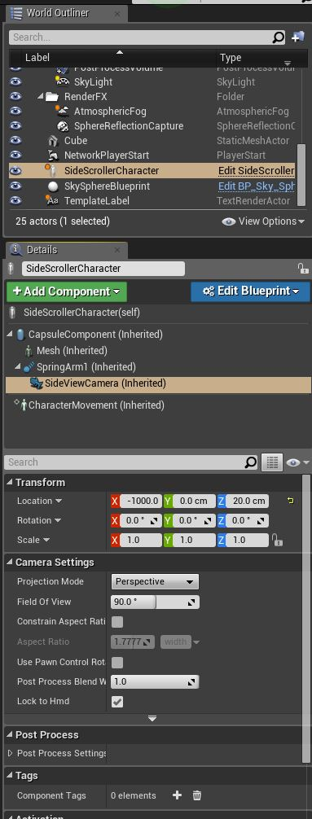Actor can also be slowed down by:

* Braking Deceleration Falling

# Camera

Camera settings are located inside the SideScrollerCharacter Object, under the name of “SideViewCamera”. See image to the right.

## Location

Use Transform->Location to set camera’s central location.

* X axis – how far in/out the camera will be from the character
* Y axis – how far left/right the camera will be from the character
* Z axis – how far up/down the camera will be from the character

## Adjusting parameters in the blueprint

See documentation in Camera Blueprint folder